Unit 12 A Health Body
Topic: Hanging up bananas
Name: __________________
Class: ______________ ( )
Date: ___________________
Scenario

One day, David goes to a fruit store to buy some bananas with his mother. He finds that all the bananas are hanged up by the shopkeeper in the fruit store.

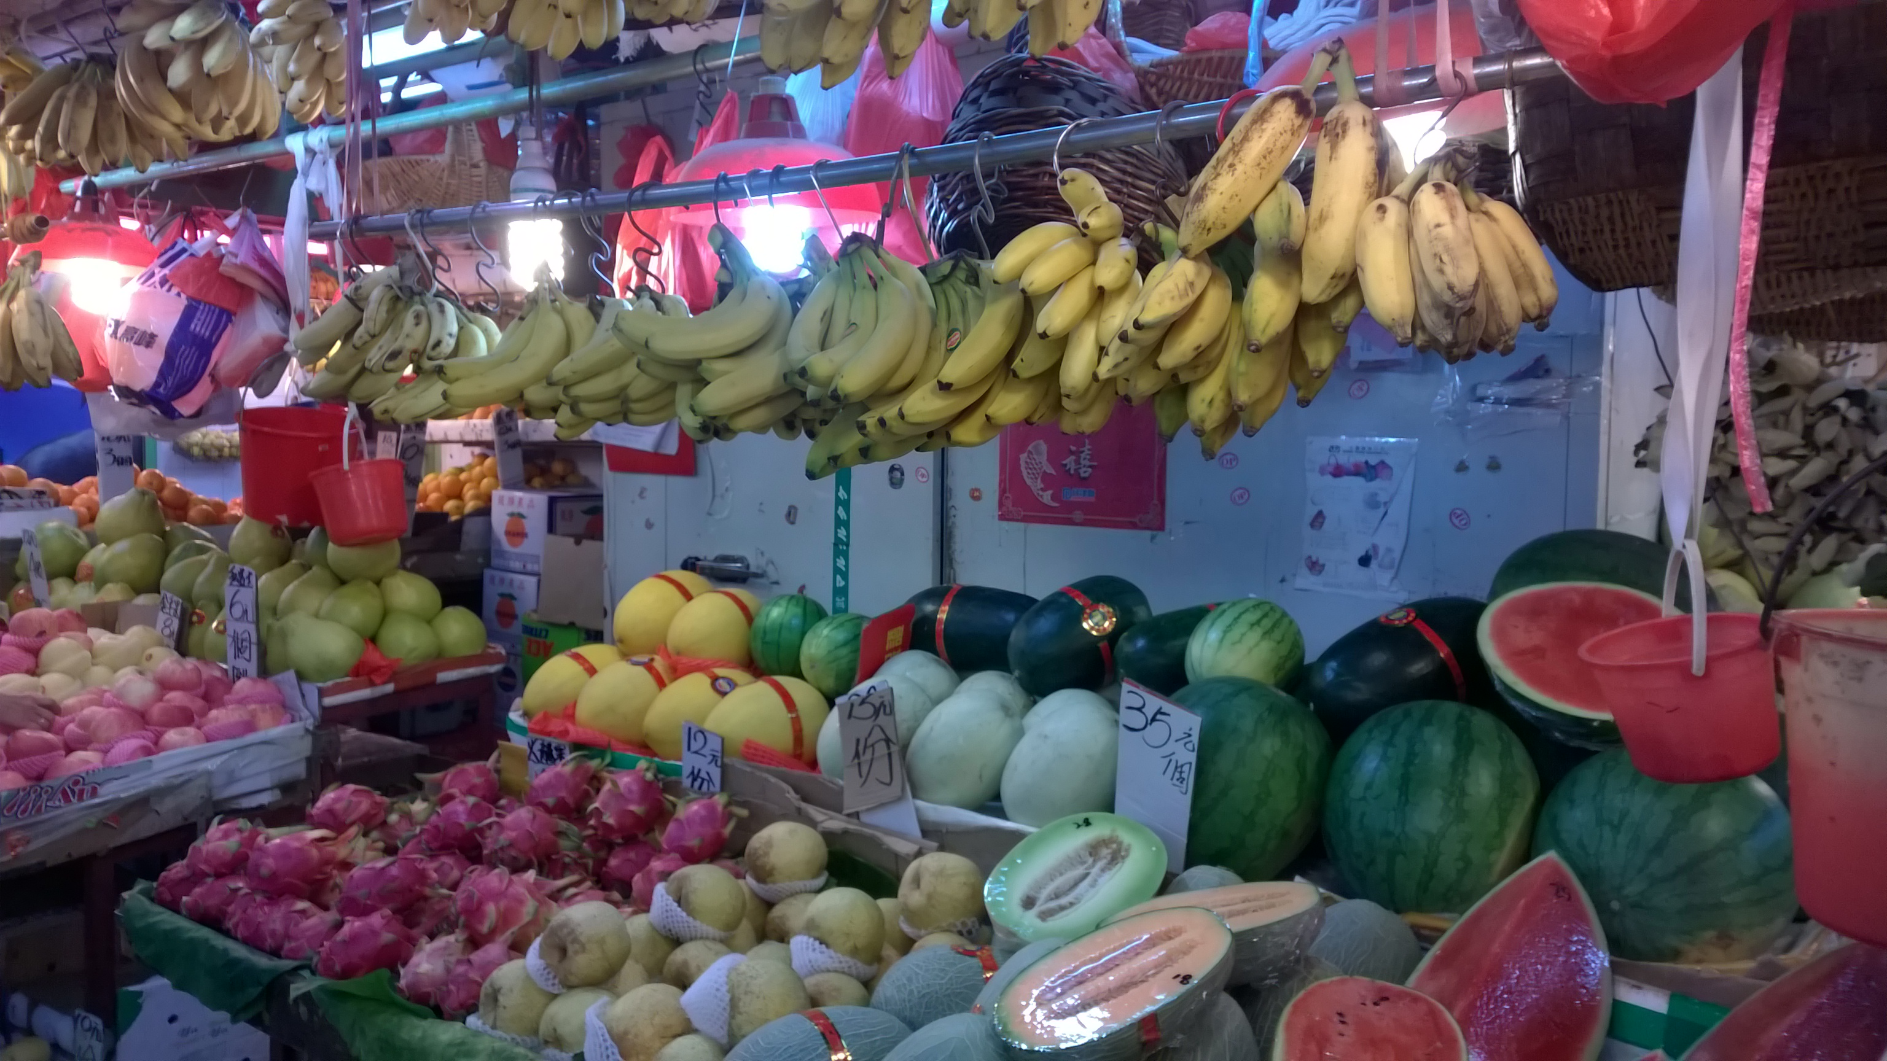

Mama, why the shopkeeper hangs up the bananas but no other kinds of fruits?
Maybe the bananas can taste sweeter after hanging up.

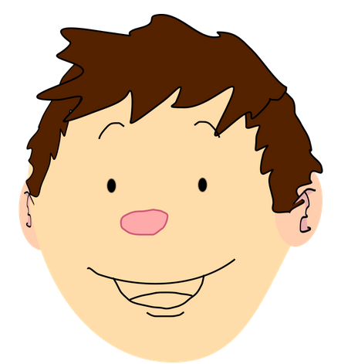


Maybe the bananas can feel like hanging on the tree.

David Mama

Task

- Which of the Mother's reasons can be tested scientifically? Design an experiment for this reason (i.e. hypothesis) and write down the procedure in the box below.
- Remove the fruit wall of two types of bananas (hanging up and lying on the table/floor).
- Weigh 10 g for each of the two samples.
- Grind the two samples separately by mortar and pestle with the addition of 30 ml distilled water respectively.
- Filer the banana solution with cheese cloth/filter paper and filter funnel.
- Mix 3 ml of each solution from the two samples with 3 ml of Benedict's solution in a test tube respectively.
- Put the two test tubes in a 80°C water bath for 5 minutes.
- Remove the two test tubes from the water bath and compare the amount of precipitates in the test tubes. (If the results are not comparable, the precipitates can be extracted and heated with oven. Its mass can be measured and compared.)

- According to your design, what are the different variables?
Independent variable: two types of bananas (hanging up and lying on the table/floor)
Dependent variable: the amount of brick-red precipitates
Control variables: mass of bananas, volume and concentration of Benedict's solution, heating duration, etc.

- Predict the experimental data if the hypothesis is correct.
(subject to students' idea)

4. Conduct the experiment with the approval of your teacher.

5. Present your data in the box below.
(subject to students' data)

6. The data from other groups may be different from your group. Can you suggest the possible reasons to explain this?
The sugar content of each piece of banana is different.
The banana samples were grinded by different persons and this affected the dissolving of sugars.
(subject to students' answers)

7. Draw a conclusion on your result.

8. Does your experimental results supporting your hypothesis? If not, propose another hypothesis and design a new experiment for it.
  - subject to students' ideas
  - students can repeat the above experiment but use different sets of banana sample:
(i) bananas placed close to other fruits like apples
(ii) banana placed alone
~END~

