Unit 9: Space travel
Topic: Friction: foe or friend?
Name: ____________________
Class: ________________( )
Date:______________________

Task 1: Friction and movement
- Watch a video about ‘Driving on icy road’.
Resource: http://www.youtube.com/watch?v=JDsclaXxy6c
Explain why it is dangerous to drive cars on icy road.
Note: This question is to elicit students’ ideas only. The following are the possible responses
- The icy road is slippery.
- The friction between the tyres and road is very low.
- It is difficult to stop the moving cars on icy roads.
Teacher could draw students’ attention on the movement of cars and friction between the tyres and road.
- Given a daily experience to illustrate what is friction.
The possible responses are:
- When a moving bus stops, the friction from the braking system stops the movement.
- When we stand still on sloping road, the friction between our shoes and the ground prevents slipping.
- When we rub our hands, the friction between our hands resists the movement. The hands will be warmer.

Task 2: Experiencing friction
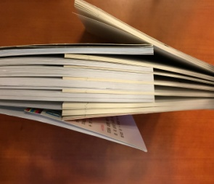
- Place two books on a table. Overlap the pages of one book to pages of another book alternately.
- Separate the two books by pulling them apart horizontally.
- Overlap the pages of two books again. Use a rubber band to hold the two books and try to separate the two books apart. What will happen as compared with that without the rubber band?
It is very difficult to pull the books apart with the rubber band binding the books.
- The resistance of pulling the books apart is called friction. Explain your answer in (3).
The rubber band increases the pressures between pages of the two books. This leads to the increase of friction between the surfaces of pages. Thus, it is difficult to pull the books apart.

- Discuss how friction can be increased.
Friction can be increased by:
- having rougher surfaces
- having a greater pressure between the surfaces

Task 3: Measuring friction
Your group is required to measure the friction between wooden block and surface of table by using:
- wooden block with a hook,
- a pulley,
- strings, and
- several weighs of mass 20 g.

- Draw your experiment set-up in the space provided below.
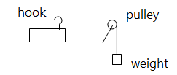

- Record the friction between the block and the table by adding the weight by 20 g each time until the block starts to move.
total weight (in g) | 20 g | 40 g | 60 g | 80 g | … | …
friction | 20 g | 40 g | 60 g | … | … | …

- What is the maximum friction between the wooden block and the table?
The maximum friction between the block and the table is XX g. We call it ‘limiting friction’.

Task 4: Factors affection friction
Your group is required to measure the maximum friction between different surfaces by using :
- wooden block with a hook,
- a pulley,
- strings,
- different materials, such as towel, plastic sheets, glass plate, and
- several weighs of mass 20 g.

- Based on the experiment set-up as Task 3, place different materials between the wooden block and table one by one.

- Record the maximum friction between the wooden block and the materials as below:
Placing different materials under the block | Maximum friction ( g )
Towel
Plastic sheet
Glass plate

- What is the conclusion can you draw from the above record?
The friction is changed by using different materials.
- Is there other factor to change the friction? Suggest an experiment to verify your answer.
The friction can also be changed by using more pressure between the contact surfaces. We can verify it by adding different weights on the block. Hence, the maximum friction will increase accordingly.

- According the above exploration, what are the factors affecting friction?
Friction can be increased by:
- having rougher surfaces
- having a greater pressure between the surfaces

- Discuss how friction can be reduced or overcome.
Friction can be reduced or overcome by:
- having smooth surfaces
- having less pressure between the surfaces
- using a lubricant such as grease and oil

