Unit 15 Light, Colours and Beyond
Topic: How do our eyes work?
Name: __________________
Class: ______________ ( )
Date: ___________________
Tasks
Part A
- A convex lens is placed between a lamp house and a white screen.
lamp house
convex lens
white screen
- When the lamp house is switched on, what can be observed on the white screen?
An image of illuminated square is formed on the white screen.

- Observe what happens on the screen when the convex lens is removed.
The image disappeared from the white screen.

- Explain how the image is formed in (a).
The light is emitted from the lamp house and transmits through the convex lens.
The lens focus the light, so that the light is refracted and forms an image on the
screen.

- Use a ray diagram to present the light path.
light from the lamp house
image is formed on the white screen
convex lens

- Close your left eye and stare at the monkey with your right eye.



(a) Draw a ray diagram to represent how light enters your eye when you stare at the monkey with your right eye.
Ray diagram showing the light which enters the eye ball

(b) Explain how you can perceive the monkey.
When the light from the environment shines on the monkey,

the light will be reflected and enter our eyes.

The light will travel through the cornea, pupil and the lens.

The lens focuses the light so that an image is formed on the yellow spot on the retina.

Signals will then be sent from retina via optic nerve to the brain
which interpret the signal.

Therefore, the monkey (image) is perceived.

(c) Hold the above page at arm’s length at horizontal level with your eyes. Close your left eye and stare at the monkey with your right eye again. Move slowly the diagrams towards yourself.
- What happens to the lion when you move the page towards yourself?
The lion disappeared at certain point when it is moved towards.

- Explain your observation in (i).
The image is formed at blind spot instead of yellow spot.
As blind spot does not contain light-sensitive cells,

no signals can be formed and sent to the brain for interpretation.

- Repeat this activity with the diagrams turned to 90°. Explain any difference when compared with the observation in (i).
The lion does not disappear at any point.

Blind spot is horizontally located next to the yellow spot.

When the diagrams are rotated, the image of lion is not formed at blind spot
but formed at other region of the retina where light-sensitive cells are present.

- Your teacher will show you some diagrams of different colored crosses. State and explain your observations.
Perception of the green colour is due to the stimulation of green-sensitive cone cells.

When we stare at the green cross for some time,
the green-sensitive cone cells become over-stimulated and then fatigue.

When we looked at the plain white screen afterwards,
the light entering our eye can stimulated only blue and red-sensitive cone cells.
These cone cells will send signals to the brain.

Thus, an image of a purple cross is perceived.

Part B
In the following section, you will learn more about different eye diseases.

- Colorblindness
There are different types of colorblindness. The diagrams below show what a normal vision person and a colorblindness patient perceived.

Normal vision Colorblindness

- Explain why colorblindness patient perceives differently.
The patient has problems in red and green-sensitive cells.

Therefore, the patient cannot distinguish the red and orange colours and
perceives the green parts.

- Cataract
Cataract is an eye disease caused by the cloudy lens in our eyes.

5. Indicate, in the diagram below, how the eye of a cataract patient is different from a normal vision person.
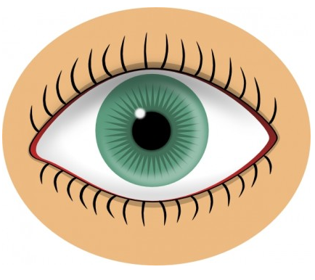

Cloudy lens can be found.

6. Explain why the cataract patient cannot see properly.
The cloudy lens blocks the lights entering and reaching the yellow spots.
As a result, a sharp image cannot be formed at the yellow spots.
The patient cannot see clearly, e.g. blurry vision.

- Macular degeneration
Macular degeneration is an eye disease because the yellow spot loses the light-sensitive cells. The following photographs show the normal vision and the vision of a patient with macular degeneration.



Normal vision Patient with macular degeneration

7. State the type of light-sensitive cell that is lost in this disease.
Cone cells

8. Explain why the vision of the patient with macular degeneration is different from normal person.
The vision becomes blurred in the center.
The central part mainly relies on the yellow spots to detect the light.

As the yellow spot contains cone cells only,
light falling on this spot can hardly be detected by the patient with this disease.

9. Browse the internet to study the cause and effect of retinal detachment.
Retinal detachment is a disease in which the retina peels away
from the underlying supporting layers.

A retinal detachment is more likely to occur in people which are extremely nearsighted,
have cataract surgery, other related eye disorders, etc.

Symptoms like a sudden or gradual increase
in either the number of ‘cobwebs’ floating about in the field of vision,

and/or light flashes in the eye.

~END~

