Unit 13 | Metals
Topic: Flame Test of metal salt solutions
Worksheet 2 – Result Sheet

Do you know that a metal salt can be dissolve in ethanol?

The following solutions will be prepared by you.
Dissolve 1g (use an electronic balance) of the salt in about 40 cm³ of 95% ethanol.

The following apparatus are available.
beakers, glass stirrers, plastic spray bottles, Bunsen burner, safety goggle

The following materials are provided.
sodium chloride (NaCl), potassium choride (KCl), calcium chloride (CaCl₂) and copper(II) chloride (CuCl₂)

1. Draft the steps that you will go through to carry out the investigation. Sketch your design of the setup.
Steps  - Weigh 1g of sodium chloride and pour it into a beaker.  - Measure about 40 cm³ of 95% ethanol and add to the beaker containing the sodium chloride.  - Stir with a glass rod to dissolve the salt. | Sketch of the setup

2. Transfer the solution into a plastic spray bottle.
3. Spray the solutions to the flame of a hot non-luminous Bunsen flame and note down
the colour of the flame.
_________bright/golden yellow_________________________________________

4. Suggest some essential safety precautions, with reasons, to be taken in the investigation.

Ethanol is highly flammable. So wear safety goggles and take care not to spray too much ethanol solution into the flame. (You can adjust the spray by turning the control knob such that the spray is smaller and more concentrated.)

Another safety measure is to do the experiment in a fume cupboard.

Results :
Complete the following table to show the colours of the metal salt solutions.

Salt solution | Colour of Flame
sodium chloride | Golden yellow | 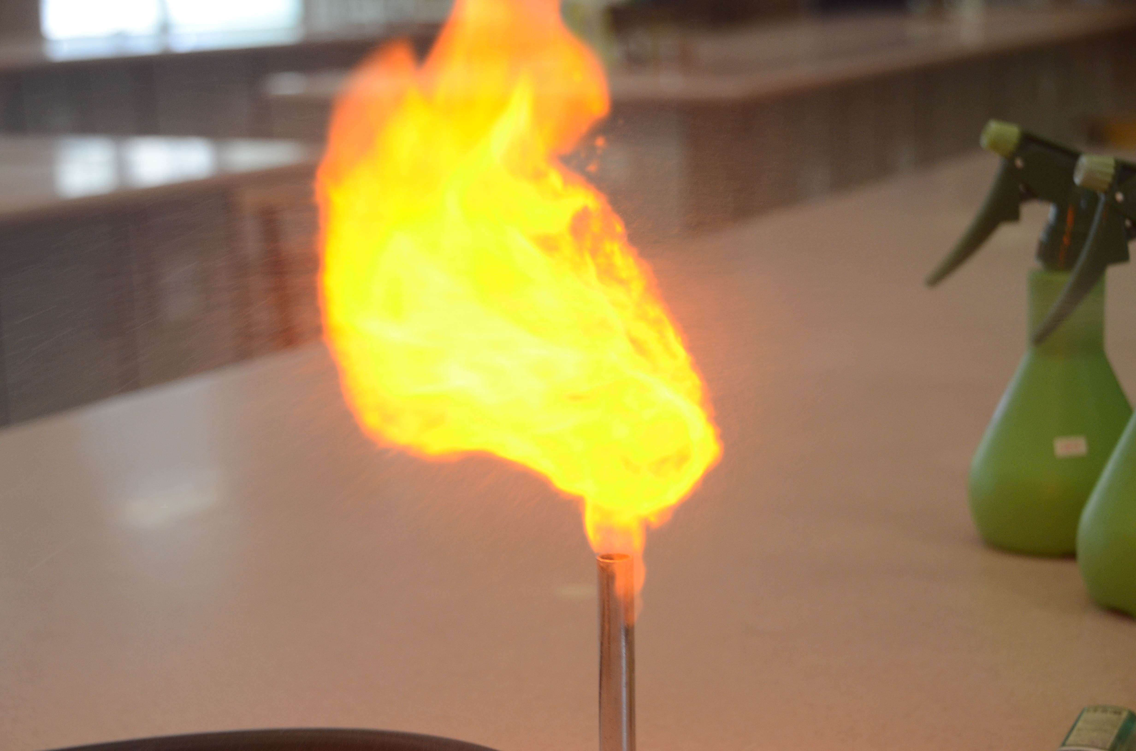
potassium chloride | Light purple  (not easy to detect) | 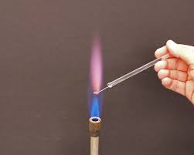
calcium chloride | Brick red | 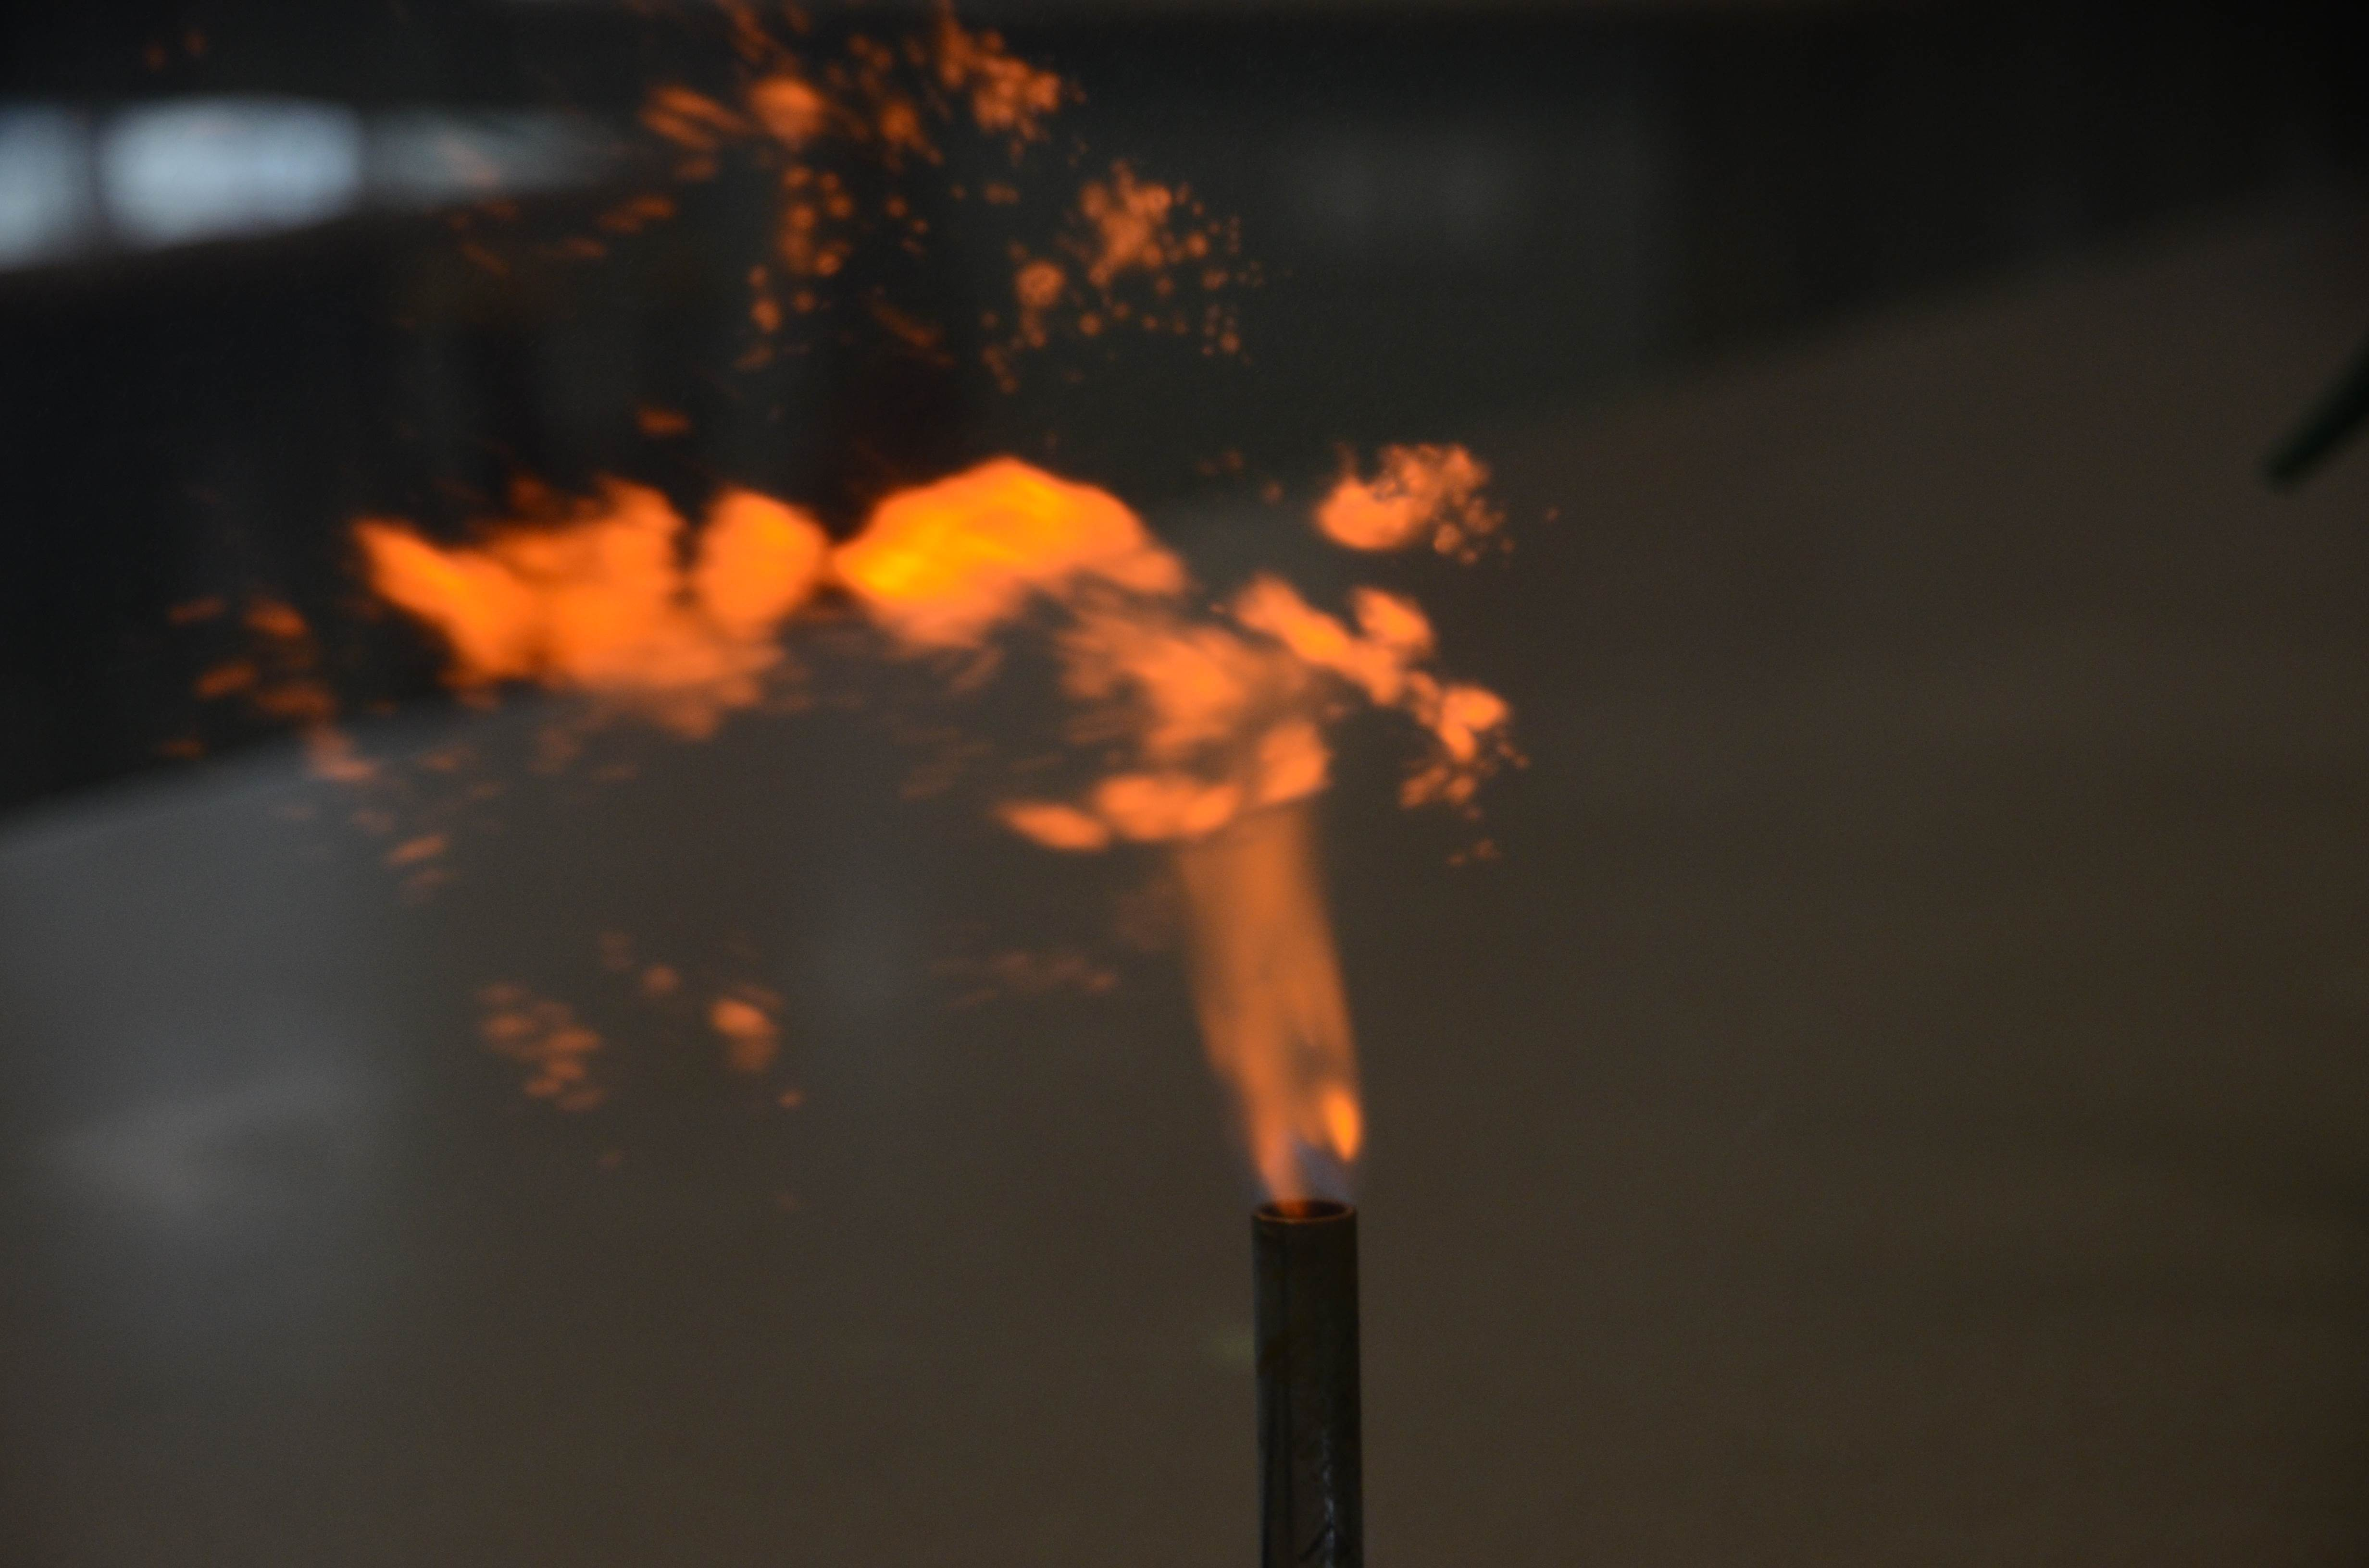
copper(II) chloride | Bluish green | 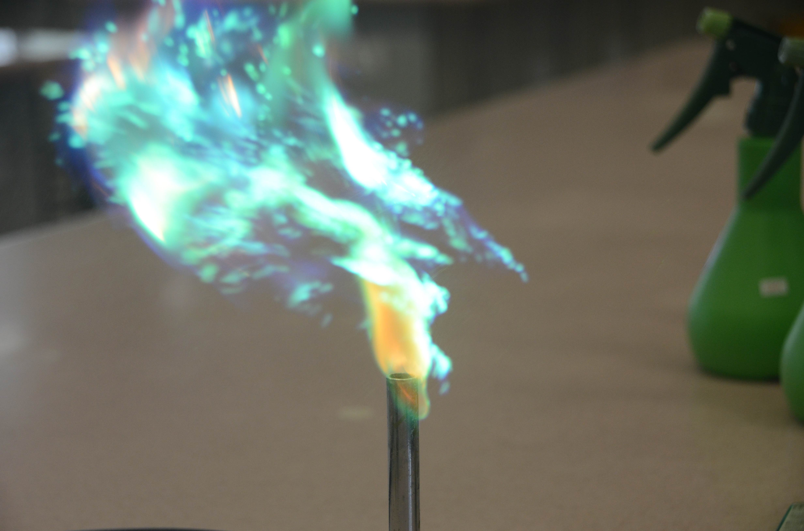

5. If the anion (chloride) is colourless in the Flame Test, what is the colour of the metals flames?

Salt solution | Colour of Flame
sodium | Golden yellow
potassium | Light purple / lilac  (not easy to detect)
calcium | Brick red
copper | Bluish green

Extended Experiment :

Try other metal salts that can be identified by the Flame Test :

Salt solution | Colour of Flame
iron(II) chloride | Yellow with sparks
barium chloride | Apple green
strontium chloride | Red (crimson)

Homework :

Application of Flame Colours - Suggest one use of the bright colour of these elements in
- Fluorescent Lights : _e.g on light, sodium lamp,
mercury fluorencent tubes______________________
- Fire works : __sodium(yellow), white (magnesium), calcium (red), copper (blue-green) etc.

The colour of many gemstones are due to the presence of Transition Metals. Suggest the metal present in
- Ruby : ___chromium________ 2) Jade : ___chromium/iron__
- Sapphire : __iron/titanium/chromium/copper___

