Unit 10 Common Acids and Alkalis
Topic: The living conditions of aquatic animals

Name: __________________
Class: ______________ ( )
Date: ___________________
Scenario
Your teacher will show a video about an aquarium.

What are the suitable conditions for us to survive in water?

Task
- Observe the apparatus used in the aquarium and explain why they are important for the survival of aquatic animals.
Air pump: To pump oxygen continuously so that animals can carry out respiration for the
release of energy.
Thermometer: To monitor the water temperature that will affect the metabolic reactions of
animals.

- There are many important conditions for the survival of aquatic animals. In this exercises, you will investigate the effect of pH. One of the commonly used animals for such scientific investigation is brine shrimp. The shrimp will die in water of unfavorable pH.
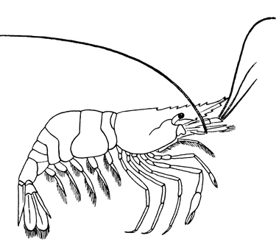

*Apparatus and materials required:
- brine shrimp | - baking soda solution (1%)
- beakers | - vinegar solution (1%)
- measuring cylinder | - pH meter
- droppers | - yeast solution
- glass rod | - water
- thermometer | - reef salt (optional for the salinity)

You are now required to design an experiment to find out the effect of pH on the population of brine shrimp. In your design, you should consider how to manipulate pH as well as control other water conditions. You may first draw your set-up and then write the procedure in the space below.

Set-up  (subject to students' ideas and feasible set-up) | Steps  - Pour 200 ml of water into four beakers.  - Measure the pH of the water and add the vinegar solution / baking soda solution drop by drop until the pH values of water in the four beakers reach pH 6, pH7, pH 8 and pH 9 respectively.  - Add one oxygen tablet and 1 ml yeast solution into each beaker.  - Add 20 brine shrimps into each beaker.  - Place the whole set-up in room temperature.  6. Add one oxygen tablet and 1 ml yeast solution each day.  7. Count the number of living shrimp each day.  8. Repeat Steps 1 to 7 continually for 7 days.

- What are the different variables in your design?
Independent variable: different pH
Dependent variable: the number of living shrimp
Control variables: volume of yeast solution (food supply), water temperature,
same amount of oxygen tablet (accept other alternatives)

- Explain why it is important to add oxygen tablet and yeast solution every day.
Oxygen tablet maintains the oxygen content in water for the respiration of shrimp.
Yeast solution is the food supply.

Oxygen and food are vital to the survival of shrimp.
Thus, the experimental data are resulted due to the change in pH
but not the other survival conditions.

5. The table below shows the number of living shrimps in 8 days.
 | Number of living shrimps
 | Day 1 | Day 2 | Day 3 | Day 4 | Day 5 | Day 6 | Day 7 | Day 8
pH 6 | 20 | 17 | 16 | 12 | 11 | 8 | 6 | 3
pH 7 | 20 | 19 | 17 | 16 | 15 | 13 | 11 | 9
pH 8 | 20 | 19 | 18 | 19 | 19 | 20 | 20 | 20
pH 9 | 20 | 19 | 18 | 18 | 16 | 16 | 16 | 16

- Present the data in the above table in the same graph.
The effect of pH on the number of living shrimps in 8 days
The number of living shrimps

20

10

0
1 2 3 4 5 6 7 8
Day
pH 6
pH 7
pH 9
pH 8

- Based on your result, what can you tell about the effect of pH on the population of brine shrimps?
In pH 6, pH 7 and pH 9, the number of living shrimps keeps decreasing.
The decreasing extent in pH 6 is the largest and that in pH 9 is the smallest.

In pH 8, the number of shrimp drops in the first three days
but rises afterwards to the original level.

- Suggest why there is a decrease of shrimp number in certain pH environment.
pH 6, pH 7 and pH 9 are unfavorable conditions for the survival of shrimps,
these conditions disturb the metabolic reactions of shrimps.
Therefore, the shrimps cannot function normally and die finally.

- Suggest why there is an increase of shrimp number in certain pH environment.
pH 8 is favorable condition for the survival and reproduction of shrimps.

When the birth rate is greater than the death rate, the population of shrimp will

increase.

(e) What is the conclusion of the study?
pH 6, pH 7 and pH 9 decreases the population of shrimps.
pH 8 maintains the population of shrimps.

- Should we use more or less shrimps for a more reliable result? Why?
We should use more shrimps to reduce the experimental error.
For example, the shrimp may die naturally due to other factors (like genetic problems)
not related to the pH condition.
Larger sample size can reduce the effect of such uncontrolled factors.
Thus, the result will be more reliable.

6. A student comments on the best pH for the survival of brine shrimps.
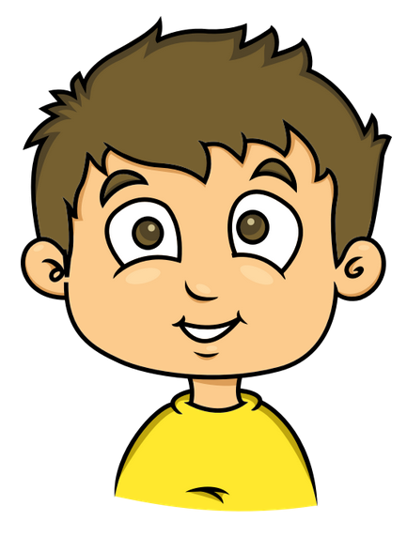
I think pH 8 but not other pH is the best pH for the survival of brine shrimps.

(a) Do you agree with this student? Support your answer with scientific methods.
We should repeat the experiment but using other pH ranged
from 7-9, e.g. 7.5, 8.5, etc.
If the repeated experiments also show a decreasing trend,
we can claim pH 8 is the best.

(b) Browse the internet to find another condition which is also important for the survival of brine shrimp. Explain how this condition may affect brine shrimp.
Salinity (i.e., the concentration of dissolved salt)

If the salinity is higher than the required level,
the shrimps will lose excessive water and then die.

If the salinity is lower than the required level,

certain metabolic reactions cannot take place and the shrimps will also die.

~END~

