Unit 7 Living Things and Air
Topic: What are the products of photosynthesis?

Name: __________________
Class: ______________ ( )
Date: ___________________
Tasks
Part A
Scenario
Two identical set-ups are prepared as the diagram below:
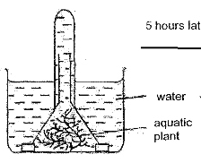
Set-up A is placed in the presence of light whereas Set-up B is placed in the dark condition for 5 hours respectively. Set-up C is similar to Set-up A but without the aquatic plant.

- Remove the test tubes from the three set-ups carefully and cover the test tubes immediately when the test tubes leave the water. Test the gas inside the three test tubes with a glowing splint and a burning splint respectively. Record the observation in the two splint tests.
In Set-up A, the glowing splint relighted but the burning splint did not give out "pop"
sound. In Set-up B and Set-up C, the glowing splint did not relight and the burning splint did
did not give out "pop" sound.

- What can be deduced from the above tests?
By comparing A and B, oxygen gas is produced in the presence of light.

By comparing A and C, oxygen gas is produced by the plants.
Overall, plant produces oxygen gas but not hydrogen gas in the presence of light.

- How can the above set-up be modified in order to find out the effect of light intensity on the products released by the plant in five hours?
The test tube can be replaced by the measuring cylinder in order to
measure the volume of gas produced in a certain period of time (i.e. five hours).

Adjust the power of light bulbs / Adjust the distance between the light source and

the plants in order to manipulate the light intensity.

- The table below shows the volume of products in Question 3.
(a) Calculate the rate of product released in the table below.
Light intensity  (arbitrary unit) | Volume of products (cm³) | Rate of product released (cm³/hour)
1 | 0.8 | 0.16
2 | 1.5 | 0.3
3 | 2.3 | 0.406
4 | 3.0 | 0.6
5 | 3.5 | 0.7

(b) What is the conclusion of the above study?
When the light intensity increases, the rate of production increases.

Part B
Scenario
Two potted plants, X and Y, are prepared.
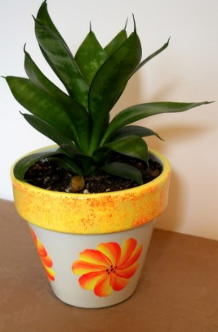

X with light Y without light

X is placed in the presence of light whereas Y is placed in the dark condition for 12 hours respectively.

- You are given with the leaves of these two potted plants. Follow the instructions of your teacher for the use of iodine solution. Record the observation on the iodine solution added on the two types of leaves.
In X, the iodine solution changes from brown to blue black.

In Y, the iodine solution remains brown in colour.

- You are given with different solutions. Test these solutions with a few drops of iodine solution. Record the colour change of iodine solution.
Only starch solution turns iodine solution from brown to blue black.

Other solutions cannot and the iodine solution remains brown in colour.

- Mix 2 g of soil samples from the two pots of plants with 5 ml water respectively. Then add a few drops of iodine solution to the two soil samples respectively. Record the colour change of iodine solution.
The iodine solution remains brown in colour.

- Based on the results of the tests in Part B, what can we know about the source of food in plant?
Soil is not a source of starch.

In the presence of light, plant produces starch by photosynthesis.

- Based on the results of the tests in Part A and Part B, what happens to the plant when it is put under light?
Plant produced starch and oxygen only in the presence of light.

- State the energy conversion for the process mentioned in Question 8 and its significance to plant. (Hints: think about why you need to eat)
Light energy is converted into chemical energy which stored as starch in the plants.

This means that plant can make its own food without depending on other sources.

The food is important for plant as it is the energy source as well as
the building materials for the growth of plant.

Part C
- You are given with other parts of the plant. Add a few drops of iodine solution on them. What can we know about the content of different parts of the plant?
Other parts of the plant also contain starch.
.

- Can we conclude that the raw potato tuber produce starch and oxygen in the presence of light? How can you support your answer?
No. We can repeat the tests in Part A and Part B, but replace the aquatic plant in Part A tubers.

and the potted plant in Part B with potato tubers in order to draw a valid conclusion.
If positive results are shown like the cases of aquatic plant and potted plant,
we can make such conclusion.

~END~

