Unit 6 Matter as Particle
Topic: The magic coke
Name: __________________
Class: ______________ ( )
Date: ___________________
Scenario
Two bottles of coke (A and B) with equal volume are used in the investigation.

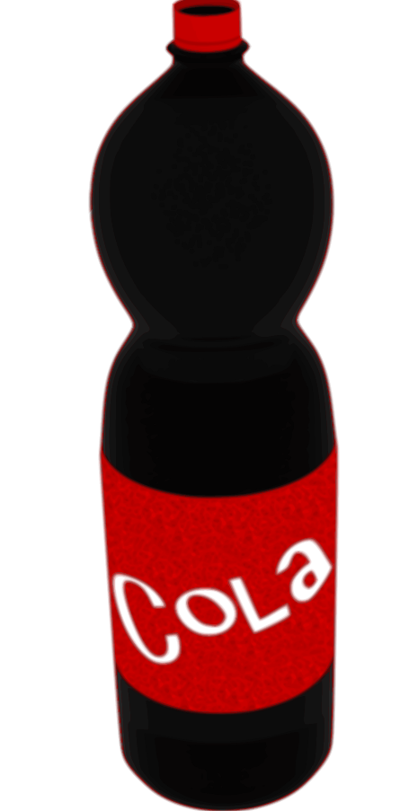

Tasks
Part A
- With reference to the concepts learnt in Unit 5, explain how you can compare the sugar content of two bottles (A and B)
The coke can be heated to undergo evaporation. The water particles will become gas
and leave the coke but the sugar just remains. As a result, we can compare the

amount of sugar remained after the evaporation of water insides two cokes.

- Write down the procedures for the investigation in Question 1.
- Measure the mass of two beakers.
- Add same volume of coke into the two beakers respectively.
- Put the cokes in the oven / heat using Bunsen burner at 100°C for 10 minutes (depending on the volume of coke used) to evaporate all the water.
(depending on the volume of coke used) to evaporate all the water.
- Measure the mass of two beakers again.
- Calculate the mass difference of the two beakers to find out the mass of solute.
- Measure the mass of two beakers.

- What are the different variables in your design above?
Independent variable: type of coke
Dependent variable: the mass of solute in the cokes
Control variables: volume of coke used, heating temperature, heating duration

- What is the assumption of your design?
Other solutes besides sugar in the two cokes are the same.
(accept other alternative)

- Construct a table to record the data you collect.
Type of coke | Sample A | Sample B
Initial mass of beaker (g)
Final mass of beaker (g)
Mass of solute (g)

- Draw a labeled diagram to show the particle arrangements of the beaker as well as the coke under heating.

water particle (gaseous state)
water particle (liquid state)
sugar / solute particle
(dissolved in water)

beaker particle (solid state)

Part B
- Instead of the evaporation method discussed above, can you propose another method to find out which sample is diet coke? Explain the rationale behind.
Subject to students' answers.

- Your teacher will illustrate a demonstration using the two bottles (A and B) of coke with same size and equal volume.
- Compare the position of the two bottles (A and B) in the tank of water.
A floats on the water surface and B sinks to the bottom.
fense
- Explain your observation in (a).
A has a lower density than B. It is because the density of A is lower than that of
water and the density of B is greater than that of water. (subject to students’ idea).

- Two bottles are now wiped dry and weighed.
- Compare their masses.
B is heavier than A.

- What do mass and volume represent?
Mass represents the amount of matter.
Volume represents the space occupied by matter.

- Refine your answer in Question 8(b) in terms of mass and volume.
A and B have the same volume but B has a greater mass than A.
Therefore, B has a higher density than A.

- Certain amount of sugar is added to Bottle A.
- Predict the new mass of A after the addition of sugar. Explain your answer.
The addition of sugar will increase the mass of A because the mass of sugar is
conserved after dissolving. Therefore, the new mass of A is equal the mass of
sugar added plus the initial mass of A.

- Describe the position of A in the tank of water again.
A sinks to the bottom.

- Refine your explanation in Question 9(c).
A and B have the same volume but B has a greater mass than A because B may
contain greater mass of sugar than A. Therefore, B has a higher density than A.

- Is there any change in the volume of A after certain amount of sugar added and completely dissolved? Explain your answer.
Complete dissolving means that all the particles of sugar are located in the
spaces between the water particles. Therefore, the overall volume does not
change.

~END~

