Unit 6 Matter as Particles
Topic: The change of potato
Name: __________________
Class: ______________ ( )
Date: ___________________

Scenario
One day, Mary helped her mother to prepare the potato cubes. She put the potato cubes in a bowl of water for cleansing. After an hour, she took them out but found that the texture of the potato cubes was changed. She wondered what had happened to the potato.
Why do the potato cubes look different?


Your teacher shows you the two types of potato cubes:
- raw potato without any treatment
- raw potato immersed in distilled water for 30 minutes

Task
- Describe the difference between the textures of these two types of potato.
The treated potato are harder than the untreated potato /
looked bigger than untreated potato.

- The initial and final masses of the treated potato cubes are now given.
- What is the change in mass of potato?
The mass of the potato cubes increases.

- Propose a reason to explain the observations in (a).
The potato absorbed water (or subject to students' ideas).

- What are the experimental set-ups required to testify your reason in (b)?
Draw a labelled diagram to present your design.
.
beakers

50 g
distilled water

10 g potato

Beaker 1 Beaker 2 Beaker 3
(subject to teacher's experiment)

- Explain the principle of design in (c).
At the beginning, certain mass of distilled water (e.g. 50 g) is added into
beakers 2 and 3 and certain mass of potato (e.g. 10 g) is prepared.
Then, the potato is added into beakers 1 and 2 respectively.
Three beakers should stand for 30 minutes (or longer).

After that, the mass of water in beaker 3 is measured to find out the amount of
water lost due to evaporation (initial volume is 50 g).
Meanwhile, the mass of water in beaker 2 is also measured and the change in mass of
water is compared with that in beaker 3.
Meanwhile, the mass of potato in beakers 1 and 2 are measured again.

If the mass of water decreases in beaker 2 is greater than in beaker 3 and
the mass of potato in beaker 2 increases greater than the mass of potato in beaker 1
This can reflect that the water is absorbed by the potato.
the decrease in mass of water in beaker 2 > the decrease in mass of water in beaker 3
This indicates that water moves into the potato.

the increase in mass of potato in beaker 2 > the increase in mass of potato in beaker 1

This indicates that water but not other factors (e.g. air) leads to
the change in mass of potato.

- Construct a table to record these data and calculate the change in mass.
The change in masses of potato and water in different set-ups.
 | Potato |  | Water
 | Beaker 1 | Beaker 2 | Beaker 2 | Beaker 3
Initial mass (g)
Final mass (g)
Change in mass (g)
(data subject to teacher's experiment)

- With reference to the particle theory, explain the mass change of potato in beaker 2.
Liquid water is made up of tiny particles which can move randomly.
The potato is made of numerous cells and the cell structures (like cell wall and cell
membrane) are also made up of other tiny particles.
There are spaces between the particles of cell wall and cell membrane.
Therefore, the water particles are small enough to diffuse across the cell wall
and cell membrane (but the particles of cell structures cannot leave the cell easily).
Thus, the potato gains water and increases in mass.

- Mary tries to put the potato cubes in a bowl of sugar solution and the cubes also become different this time.
The potato cubes this time become softer and lighter in mass. Why?

- What particles does the sugar solution contain?
Sugar particles and water particles

- Suggest why there is such change in potato.
The sugar particles are too large so they cannot diffuse across the cell wall
and the cell membrane. Thus, the sugar particles cannot be absorbed by potato cells.

Meanwhile, the potato cannot gain mass from water absorption.
Instead, some small particles may leave the cells to cause the decrease in mass
of potato.

- Draw a labelled diagram to show the structure of a potato cells in this case.
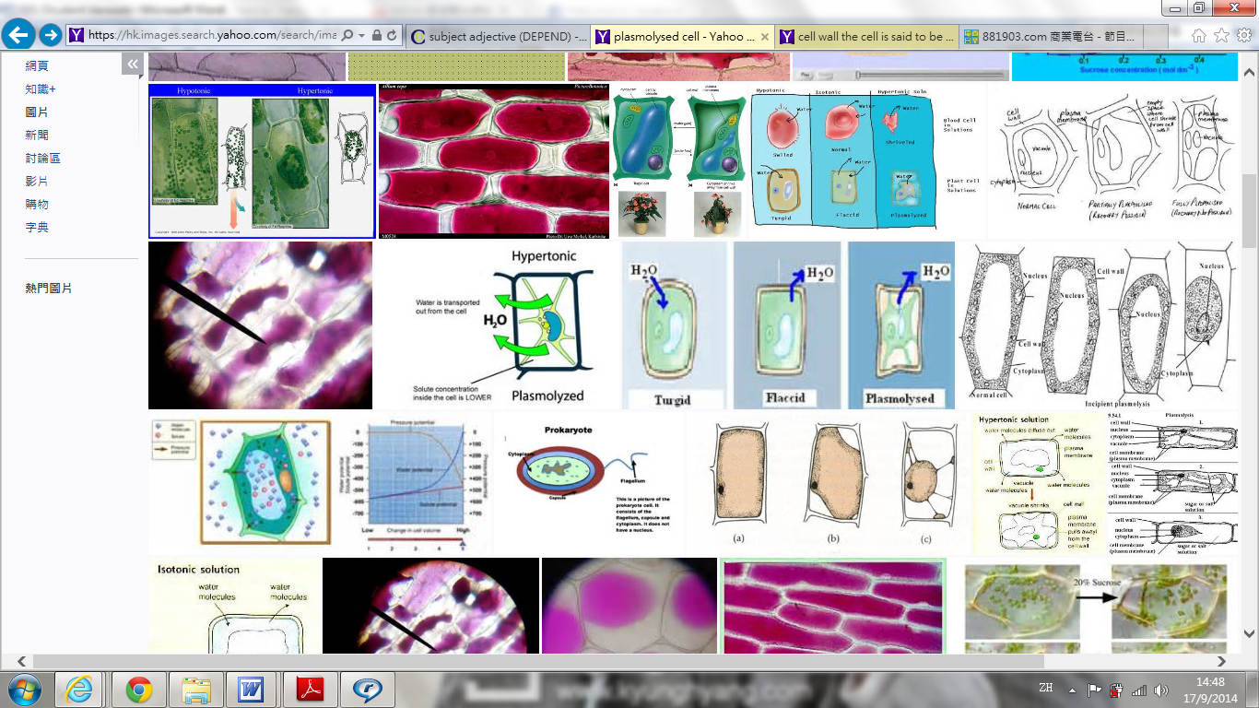
cell Wall

nucleus
cytoplasm

cell membrane

The potato cell immersed in sugar solution
The colour of cytoplasm is for display purpose.
No shading is needed in students' drawing)

- Draw the particle model to represent (i) the particles of cell wall and (ii) the particles found in the space between the cell wall and the cell membrane in your drawing.
(i)  the particles of cell wall | (ii)  the particles (of sugar solution) found in the space between the cell wall and the cell membrane
~END~

