Unit 6 Matter as Particle
Topic: Heating ice to steam
Name: __________________
Class: ______________ ( )
Date: ___________________

Scenario

Two students, Peter and Mary, are asked to predict the shape of graph to show how the temperature would change when ice is heated to steam.
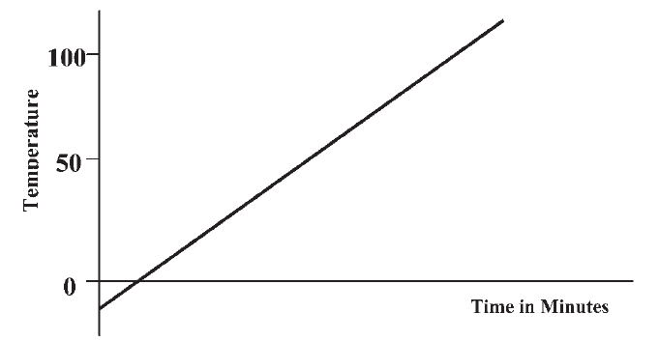

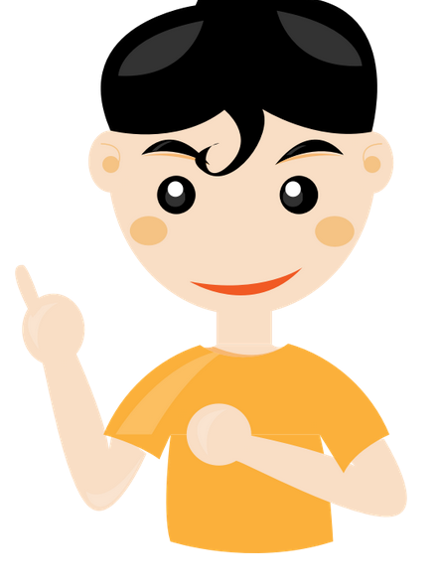

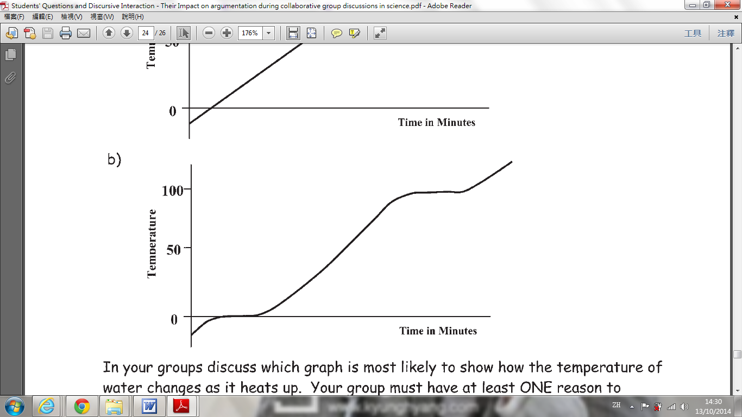

Peter

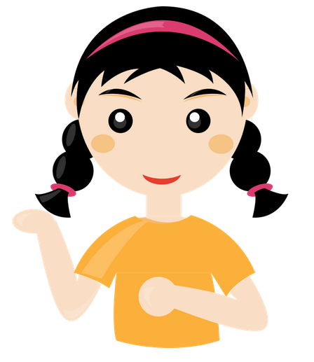

Mary
Task

- Which student do you agree with? Explain your answer with at least one reason.
subject to students' idea

- Your group is given the apparatus and materials to find out the temperature change when ice is heated to steam. Tabulate the data below.
Time (min) | Temperature (°C) | Observation
(subject to students' data)
(Remark: The time is subject to the mass of ice used.)

- Based on the data collected, plot a graph to show the temperature change.

(similar to the graph from Mary's idea)

- Describe and explain the shape of the graph.
- During 0 min - 3 min (subject to the students' data), the temperature increases from -4°C to 0°C. It is because the ice absorbs the heat energy from the Bunsen burner.

- During 3 min - 8 min (subject to the students' data), the temperature does not change because the heat energy from the Bunsen burner is used to break the bond/attractive force between the water particles, which turns the solid state into liquid state.

- During 8 min - 15 min (subject to the students' data), the temperature increases from 0°C to 100°C. It is because the liquid absorbs the heat energy from the Bunsen burner.

- During 15 min - 22 min (subject to the students' data), the temperature does not change because the heat energy from the Bunsen burner is used to break the bond/attractive force between the water particles to turns the liquid state into gaseous state.

- Compare your answers in questions 1 and 4. Write down what additional information you learn after the investigation.
subject to students' idea

~END~

