Unit 2 Looking at Living Things
Topic: The diversity of forms among living things
Name: __________________
Class: ______________ ( )
Date: ___________________

Task 2: An investigation into the way of communication

Scenario
Scientists have not been sure about how horses communicate. They propose that horses may use ear and eye to communicate with each other. Imagine if you were those scientists, what would you design to testify these ideas about the uses of ear and eye in horses for communication?
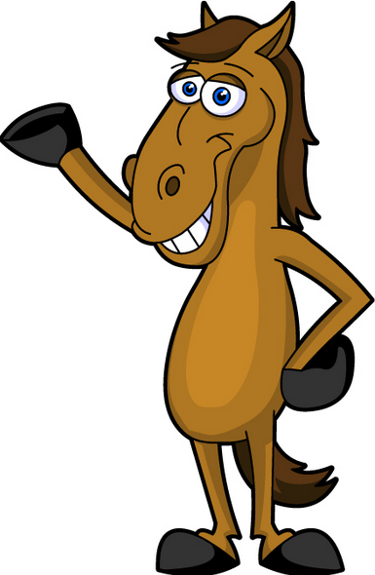
Do you know how we communicate? Design an experiment to test your idea.

Task
- Propose one way about how horses communicate with each other.
e.g. Horse produces and detect sounds. / Horse communicates by body contact.
(Accept other alternatives)

You may first draw your set-up and write the procedure in the space below.
Set-up  (subject to students' ideas and feasible set-up) | Steps

- In your design, what are the variables?
Independent variable: subject to students' ideas and feasible set-up
Dependent variable: subject to students' ideas and feasible set-up
Control variables: subject to students' ideas and feasible set-up

- Your teacher will show you how the scientists have tested their ideas involving 72 horses.
- Based on Set-up 1 and Set-up 2, what did the scientists suggest about the way of communication in horse?
Scientists suggested ear is required in communication.

- What are the variables of the above design?
Independent variable: cover the ear or not
Dependent variable: the number/the percentage of horse choosing the two buckets
Control variables: same types and amount of crops, same species of 72 horses, same horse picture (accept other alternatives)

- Scientists made the third set-up. What is the purpose of such design?
Scientists suggested that eye is required in communication by comparing this set-up
with Set-up 1.

- The following tables showed the percentage of selection.
 | Set-up 1
 | Left bucket | Right bucket
Percentage of selection (%) | 25% | 75%
 | Set-up 2
 | Left bucket | Right bucket
Percentage of selection (%) | 50% | 50%
 | Set-up 3
 | Left bucket | Right bucket
Percentage of selection (%) | 50% | 50%

- What can be deduced about the preference of horse in each set-up?
Set-up 1: | Higher percentage of horses (75%) prefer right bucket to left bucket (25%)
Set-up 2: | No preference could be indicated as the percentages of both sides are the same.
Set-up 3: | No preference could be indicated as the percentages of both sides are the same.

(ii) Based on the above results, draw a conclusion about the ways of communication in horse.
By comparing Set-up 1 and Set-up 2, the presence of ear guides more other horses
to choose the bucket on the side which the ear faced towards.

By comparing Set-up 1 and Set-up 3, the presence of eye guides more other horses
to choose the bucket on the side which the eye faced towards.

- What additional set-up can be done to further strength your conclusion in (ii)?
Repeat Set-up 1 but using the horse picture facing the left bucket and observe
if similar data can be collected in which about 75% of horses select the left bucket.

~END~

