Unit 2 Looking at Living Things
Topic: The diversity of forms among living things
Name: __________________
Class: ______________ ( )
Date: ___________________

Task 1: A study on communication of living things

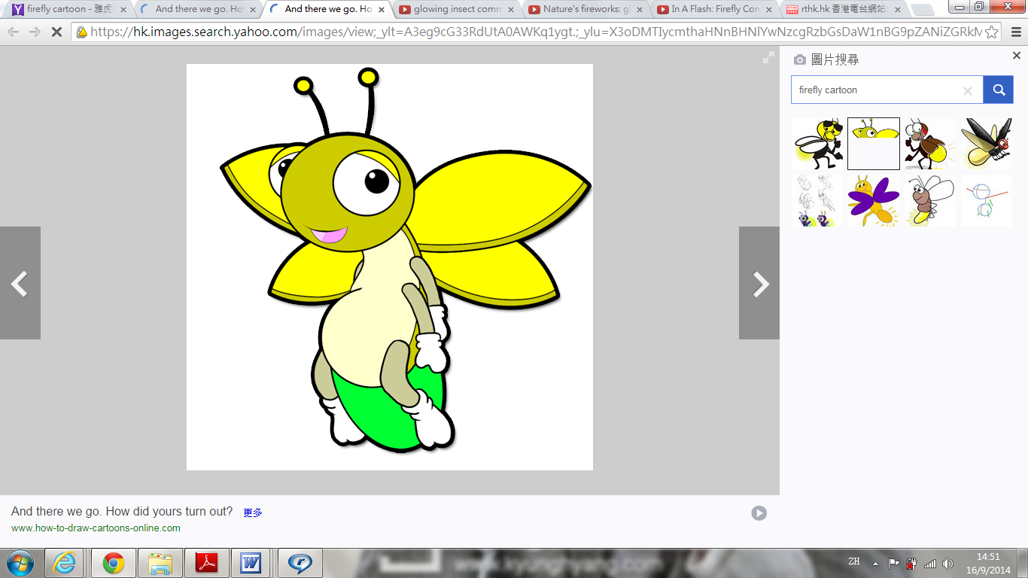
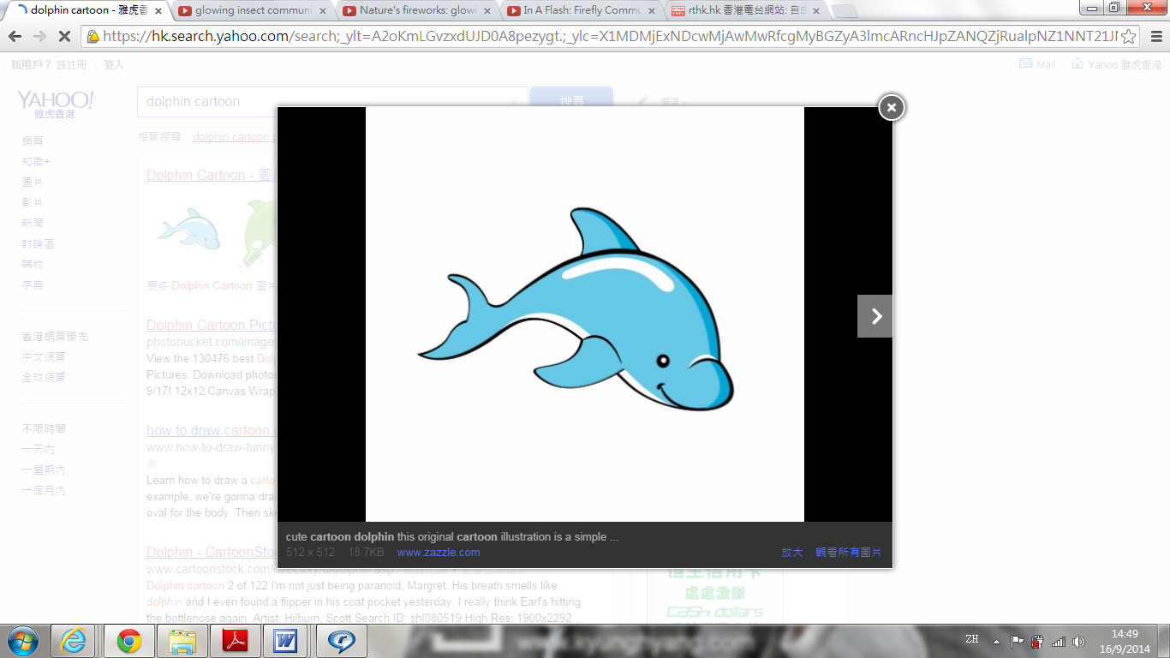
How do we communicate?

- Do you know how other living things communicate with each other? Watch the two videos. Identify the different ways used by the two living things and the importance of such communication.
Dolphins emit sounds so that they can know each other and do same action/response for fense
defense in nature.

Fireflies emit light from their last body segment so that they can attract mates
for reproduction.

- Predict how the above two living things are able to communicate by different body structures.
Dolphins have special nasal passage to produce high-pitched sound and have special ear to defense
detect such sound (that human may not).

Fireflies have special chemical substance to emit light and detect the light by the (compound) eyes.

compound eyes.

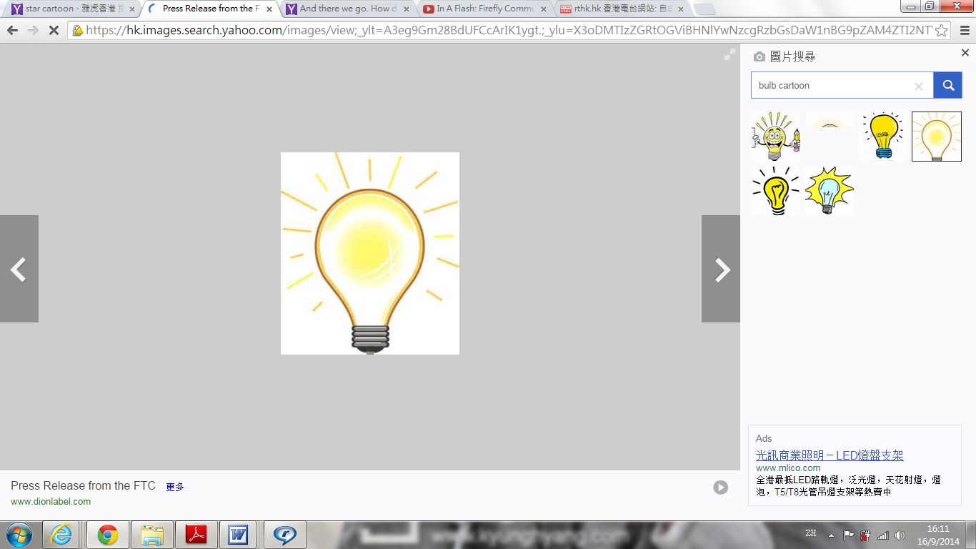Key point
Living things can react to stimuli with different ways because they have different
body structures to produce and detect different signals.
Therefore, diversity of forms exists among the living things.
~END~

