Unit 1.4 : Conducting a simple scientific investigation
Topic : Energy loss in a collision
Worksheet 2
Name : __________________
Class: _______________( )
Date: ___________________

Some people suggest that different surfaces will affect the bouncing motion of a football. Since there is limited space in laboratory to investigate the bouncing motion of football, we study the bouncing motion using a table tennis ball and a tennis ball respectively.

Task 1: Design a test to compare energy loss of a ball bouncing on hard and soft surface

- Objective

To investigate when a ball bounces on a soft or hard surface, which one has greater energy loss in the collision?

- Hypothesis

As compared with that on hard surface, the ball that hits on the soft surface will bounce up higher / lower. This shows that it has higher/lower energy loss in the collision.

- Material used / Equipment:
Put a tick ✓ on the material you would use in this investigation

 Ping Pong Ball  Stop watch  Meter ruler  Cloth  Tennis Ball
 Others: _________________

- Procedure: Complete the following procedure and measure the bouncing height of a table tennis ball. Repeat the test three times and record the measurements. (Experiment A)

(a) Place the table tennis ball at 1.5 m above the hard floor.  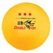  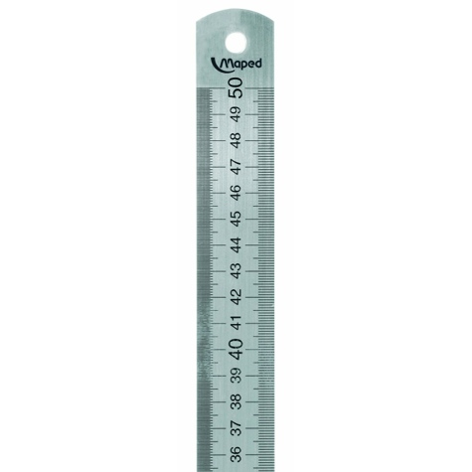 | (b) Mark and measure the position of first bouncing height .

c) Place a cloth or blanket on the floor. Repeat Step (1) , (2)

d) Repeat Step (1) to (3) with a tennis ball.(Experiment B)

5. Results:
Experiment A
First rebounding height (cm) of table tennis ball | 1st time | 2nd time | 3rd time | Average height
- On hard floor
- On floor with cloth/blanket

Experiment B
First rebounding height (cm) of tennis ball | 1st time | 2nd time | 3rd time | Average height
- On hard floor
- On floor with cloth/blanket

6. Discussion

- Why should we repeat the test several times and take the average value?
It will reduce errors and increase the reliability of evidence.

- Complete the following diagram to show the energy changes of the ball in the rebounding motion

__PE____ Ball at highest point
___KE___
Ball falls on the ground
__PE____
Ball rebound to highest point
+

Some_energy is lost as heat_& sound_
Ball hitting at the ground

- By comparing the first rebounding height from both surfaces in experiment A, in which case more energy is lost in the collisions?
In experiment A, the results show that the renouncing height of table tennis ball colliding on soft surface is lower than that on hard surface. Thus the energy loss is greater when the ball are bouncing from a soft surface.

- Is the same conclusion about the energy loss drawn for experiment B ?
Yes.

- Is your hypothesis correct?

Task 2: Is it a fair test?

- State one difference between experiments A and B.

Table tennis ball is used in experiment in A while tennis ball is used in experiment B.

- State two similarities between experiments A and B.

- The balls are falling from the same height in both experiments.
- The balls are kept unchanged during each experiment.
- Consider the following experiment results.

First rebounding height (cm) | Average height
- A jelly ball hitting on a hard surface | 2 cm
- A tennis ball hitting on a soft surface. | 28 cm

John draws a conclusion from the data above.
“The rebounding height on hard surface is lower than that on soft floor. Thus the energy loss in collision with a hard surface is greater”. Comment on John’s conclusion.
We cannot draw such conclusion from the data given. They use different types of balls.

- In designing a fair test, what important thing we should notice?
A fair test requires all the conditions remain unchanged with one variable under investigation at one time.

