Unit 1.4 : Conducting a simple scientific investigation
Topic : Energy loss in a collision
Worksheet 1
Name : __________________
Class: _______________( )
Date: ___________________
- The importance of surface

Watch the news about a football match in July 2013.



Reference video :
http://www.youtube.com/watch?v=ut1ISvzMJhU
http://youtube.com/watch?v=kWfMEuQWlqM

Why can’t the football players perform well in the match?
The bouncing height of the ball is hard to predict in a wet playground.

What happen to the bouncing height of the football on wet playground?
In a wet playground, the bouncing height of the football is lower than normal.

- Energy change of a bouncing motion

Knowledge about energy
Kinetic energy (KE) of a ball is related to its speed. The greater its speed is, the greater its kinetic energy.

Potential energy (PE) stored in a ball is related to its height. The higher its height is, the higher its potential energy.

Change of energy of a bouncing ball

The following shows the energy of a bouncing ball at different positions.

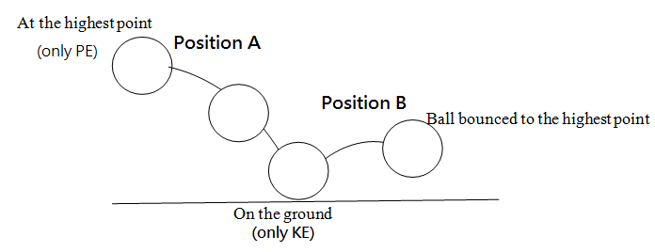

- Describe the energy change of the above bouncing motion.

When the ball falls down from position A on the ground, the potential energy stored in the ball changes to its kinetic energy.
When the ball bounces up to position B, the kinetic energy changes to the potential energy stored in the ball.

- Considering the potential energy stored in the ball at position A and B, are they the same? Explain your answer.

The potential energy stored in the ball at position A is greater than that at B. The bouncing height is lower than the original height. This is an energy loss in the collision between the ball and the surface.

