Unit 1 Introducing Science
Topic: Flying of twirly

Name: __________________
Class: ______________ ( )
Date: ___________________
Scenario
‘Doraemon’ can fly because it uses a twirly.
In this lesson, let's make a twirly and investigate its flying.

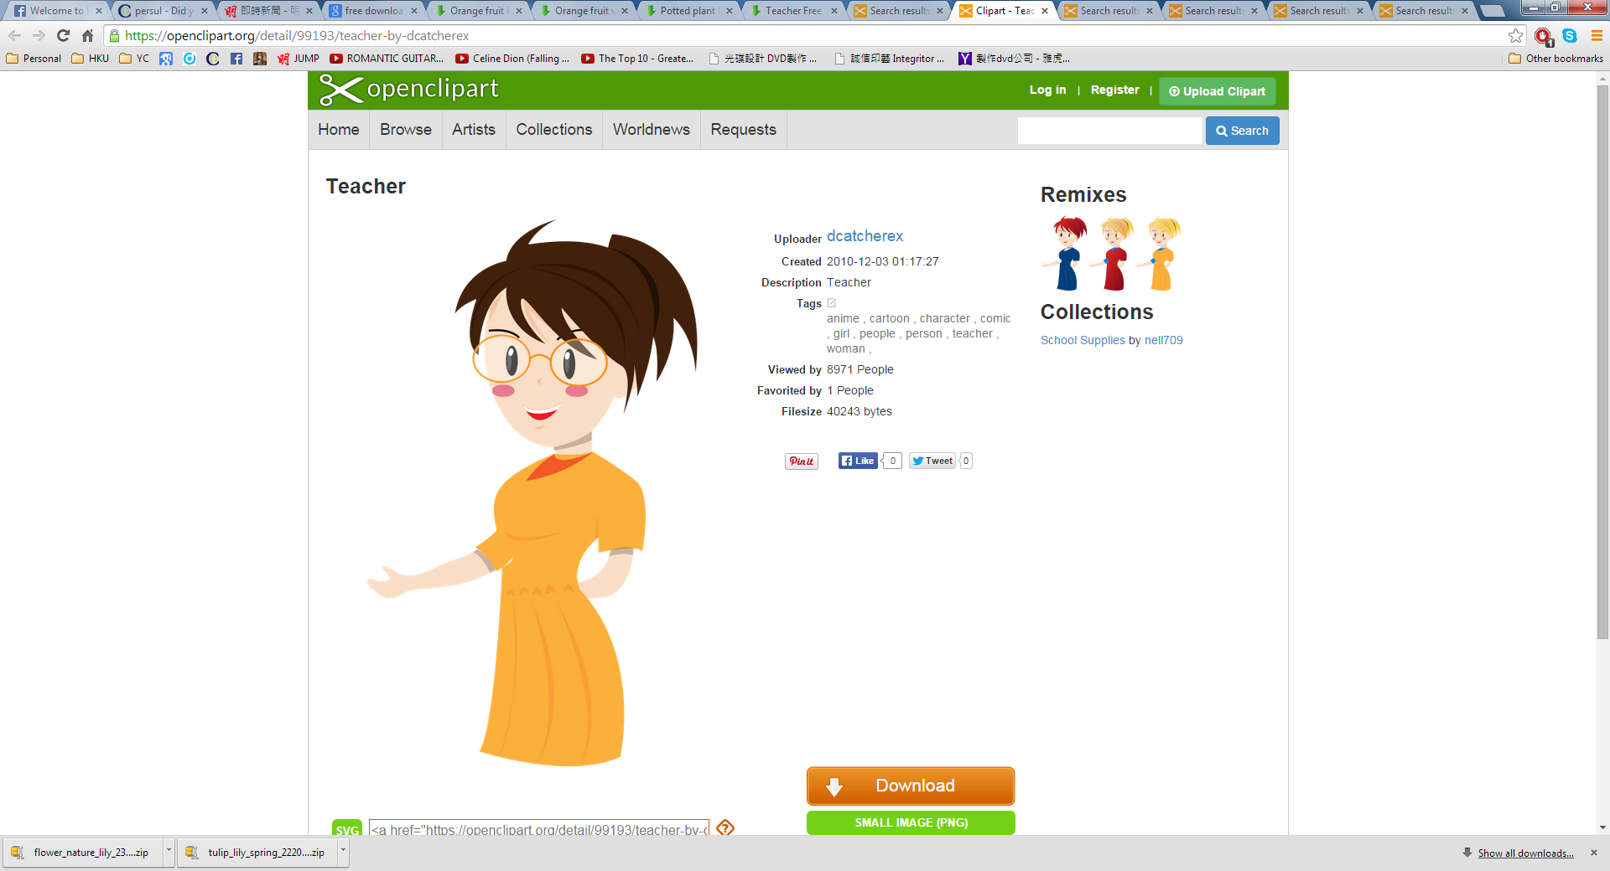

Task
- List THREE internal factors that will affect the flying time of a twirly in the air.
(i)
(ii)

(iii)

- Choose one of the above factors for your investigation. Present your design in the box below and then write down the procedures afterwards.
The factor studied:___MASS OF TWIRLY___________________________
- One twirly by following the template instruction.
- Attach one clip at the bottom of the twirly.
- Free fall the twirly from height.
- Measure the flying time of twirly (i.e. the duration between the time when it is released and the time when it once lands on the ground).
- Repeat step iii and iv for more data.
- Attach two clips at the bottom of the twirly and repeat step iii and v.
- Do more trials with different number of clips.

- According to your design, what are the different variables?
Independent variable: number of clips / mass of twirly
Dependent variable: the flying time of twirly
Control variables: the dropping height, the same twirly, etc.

- Predict the experimental data.
When the mass / number of clips increases, the flying time will decrease.

- Present your data in the box below..
(subject to students' data)

- Draw a conclusion on your result.
When the mass / number of clips increases, the flying time will decrease.

- Do you think your method is reliable? Why?
Yes, because several data were collected for each mass of twirly (accept other alternatives).
OR

No, because the flying time was also affected by the wind speed which was different during trial
each trial / the reaction time of the classmates may vary (accept other alternatives).

- If you are going to study another factor stated in Question 1, what will you adjust your current procedures?
Prepare twirlies of different surface areas without any clips. Then repeat the procedures
as in the above procedures.
Or
OR
Prepare twirlies made up of different materials (like plain paper, cardboard, tissues paper)
but same surface area. Then repeat the procedures as in the above procedures

- Report your data of the second investigation in the space provided
(subject to students' data)

Conclusion:

~END~

