Unit 1 Introducing Science
Topic: Extraction of orange juice
Name: __________________
Class: ______________ ( )
Date: ___________________

Scenario
One day, Peter and Mary would like to drink orange juice. However, they do not have the juice blender or squeezer.
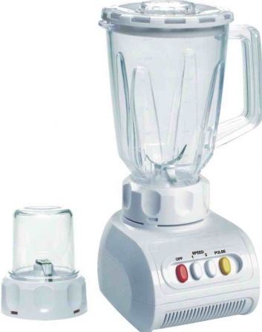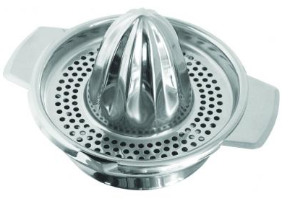

Therefore, they decide to extract the juice by bare hands with the help of a knife. Each of them suggests different cuttings on the orange.

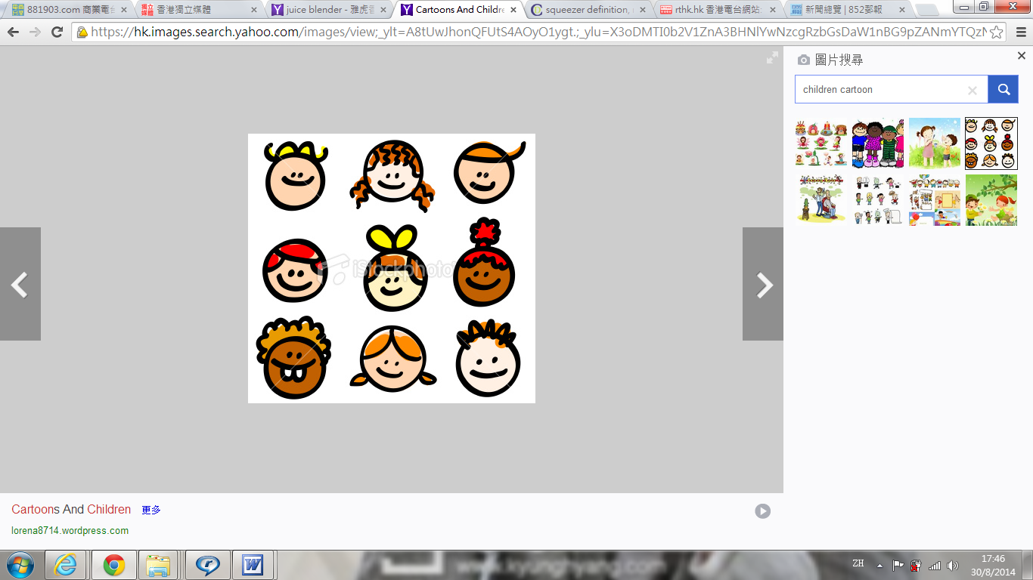
I guess we can just cut the orange into two half to extract the most juice.

Peter

I don’t agree. We should cut it into to more slices to extract the most juice.

Mary

Task
Design an investigation to find out whether cutting orange into more slices can extract more juice.

- Describe how we can accurately measure the amount of juice with the use of different measuring instruments in laboratory.
Measuring mass by (electronic) balance
Measuring volume by measuring cylinder

- How can we fairly compare the amount of juice extracted by the two methods?
Only the method we use can be changed. Other conditions should be remained the same
when we apply the two methods. Besides, only one orange is used to be tested for the two

methods, i.e. we cut one orange into two halves and each half is for one method. This can
ensure that the original volume of juice is (almost) the same before being tested by two
methods.

- We use the volume of juice extracted for comparing the two methods. What is the assumption behind?
The original volume of juice in the sample oranges is the same.

- Using the space below, draw a diagram(s) to present your set-up.
- Cut one orange into two equal halves (label as A and B).
- Cut A into two equal slices (student can decide whether the fruit wall us removed or not).
- Squeeze juice by mortar and pestle.
- Filter the juice by filter paper and filter funnel.
- Measure the volume of juice collected by measuring cylinder.
- Cut B into four equal slices.
- Repeat step iii to v with the slices of B.

- According to your design, what are the different variables?
Independent variable: number of slices
Dependent variable: volume of juice collected
Control variables: grinding force, all slices with/without fruit wall, etc.

- Record your data below.
(subject to students' data)

- Draw a conclusion on your result.
(subject to students' data)

- Other groups show different results to yours. Can you suggest the possible reasons to explain this?
The orange used by each group is different. The grinding force exerted by each group is
different. It is possible that the juice is absorbed the filter paper and the volume of
absorption is different in each group. (accept other alternatives)

- Can you propose another measurement if your assumption in the present study above is not valid?
Measure the change in mass of orange and calculate its percentage change.

First, repeat step i and ii as in the above design. Measure the total mass of orange by the
balance. Repeat the steps iii and iv as in the above design. Measure the mass of treated
orange again after the extraction. Calculate the change in mass and then the percentage
change in mass. Greater percentage change indicates more juice being extracted.
$$\frac{\text{initial mass}−\text{final mass}}{\text{initial mass}}×\text{100\%}$$
Percentage change =

~END~

